## **Creating a playlist on Spotify**

**Feature description**

Spotify is a digital music, podcast, and video service. The Spotify - Web player is available for desktop browsers. The Spotify app can be also downloaded for desktop or on any other like Android or OS.

A Spotify playlist is a way to organize tracks, podcasts, and episodes. The app allows the users to arrange favourite music, establish it by mood. Songs can be added from the personal Library or Search section, where the users can find needed tracks.Spotify playlists allow users to remove music with simple actions. Playlists on Spotify can be created, modified and customized. The playlist can have a name, description and cover provided by the user. Playlist is shareable through links or Social Medias, so users can expose their musical tastes and others may discover new music within those playlists.

**About this task**

On the Spotify app you can manage your music and create your own playlist. Spotify playlists are ideal for organizing music by specific themes, genres, moods, or activities such as workouts, studying, or relaxing. They are also an excellent tool for exploring Spotify's features, such as automated suggestions.

**Before you begin**

Make sure:

1. You have installed the Spotify app on your device
2. You are logged in your account.

**Procedure**

1. Open **the Spotify** app.
2. Tap **My Library**.
3. At the top of the screen, tap **Plus.**
4. In **the** **Plus** list, tap **Playlist**.
5. Name your playlist and tap **Create**.
6. Tap **Add to this playlist** for suggestions.

(Optional) You can see all the options by swiping to the left: you are able to add music or podcasts from Spotify Suggested or Recently played or Your Favorites.

1. Choose the songs or podcasts and tap **Plus**.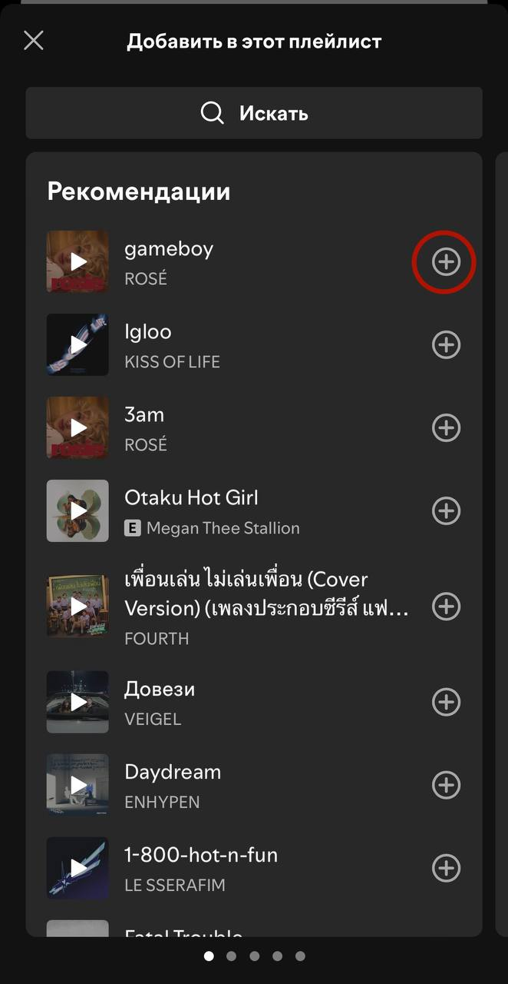
2. (Optional) To remove tracks, do the following:

a. Tap **Three dots** andin the **Three dots** list, tap **Edit playlist**.

b. Tap **Munis** and at the top, tap **Save.**